**How to use Json Extractor in JMeter**

**--** Most of the servers send json in compact format in the json response, skipping indentation. This is done for performance reason

-- This reduces bandwidth usage and server CPU usage.

-- To debug the script, we can add JP@GC JSON Format Postprocessor to view the Json response in the formatted way

-- Link to download the above Plug-in:- [**https://jmeter-plugins.org/?search=jpgc-json**](https://jmeter-plugins.org/?search=jpgc-json)

**--** Now let’s take an API which gives JSON response. API=**https://reqres.in/api/users?page=2**

-- Below is response data which comes as a response if we hit the above API

{

"page": 2,

"per_page": 6,

"total": 12,

"total_pages": 2,

"data": [

{

"id": 7,

"email": "michael.lawson@reqres.in",

"first_name": "Michael",

"last_name": "Lawson",

"avatar": "https://s3.amazonaws.com/uifaces/faces/twitter/follettkyle/128.jpg"

},

{

"id": 8,

"email": "lindsay.ferguson@reqres.in",

"first_name": "Lindsay",

"last_name": "Ferguson",

"avatar": "https://s3.amazonaws.com/uifaces/faces/twitter/araa3185/128.jpg"

},

]

}

-- Now we will be writing some JSON Path Expressions to extract some values from the json response

1. To extract all values of first name

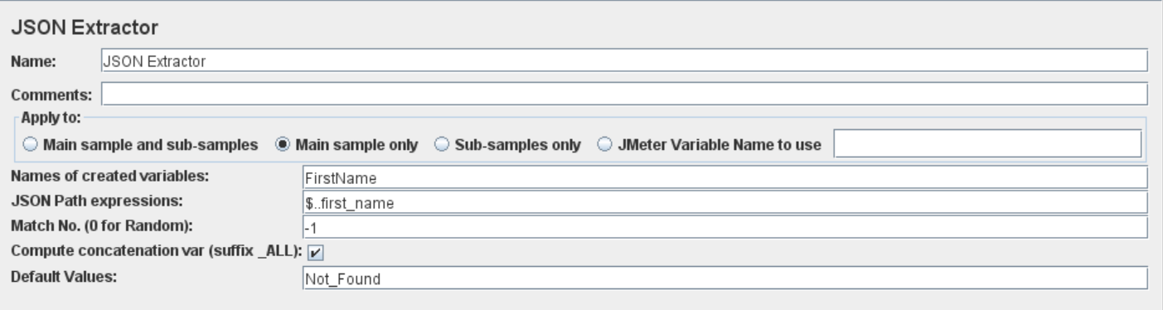

Output Values=

FirstName_1=Michael

FirstName_2=Lindsay

FirstName_3=Tobias

FirstName_4=Byron

FirstName_5=George

FirstName_6=Rachel

FirstName_ALL=Michael,Lindsay,Tobias,Byron,George,Rachel

FirstName_matchNr=6

1. To extract any random value of first name

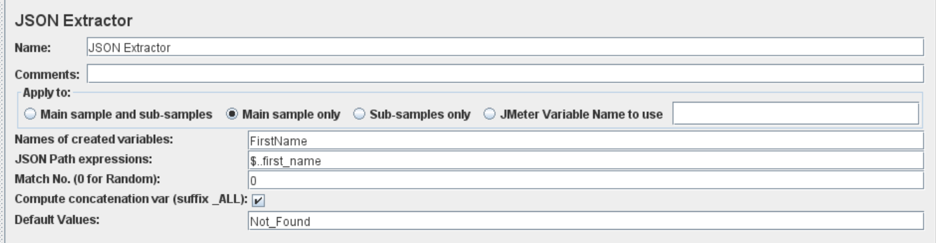

Output Values=

run1=FirstName=Tobias

run2=FirstName=Byron

1. To extract first name from 2nd data level i.e. ‘Lindsay’

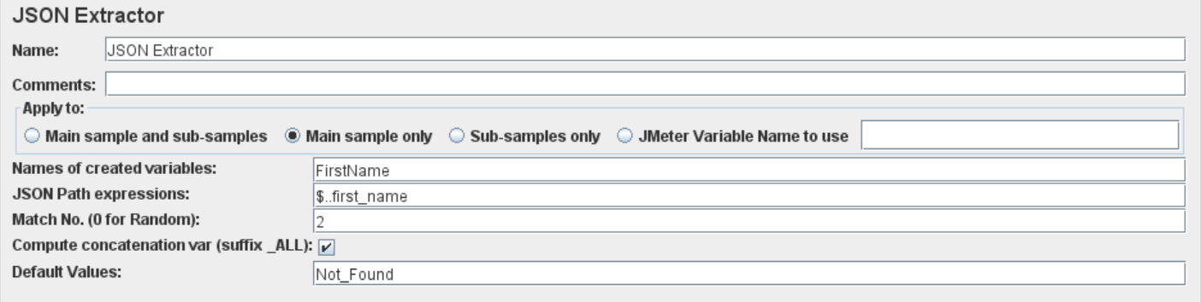

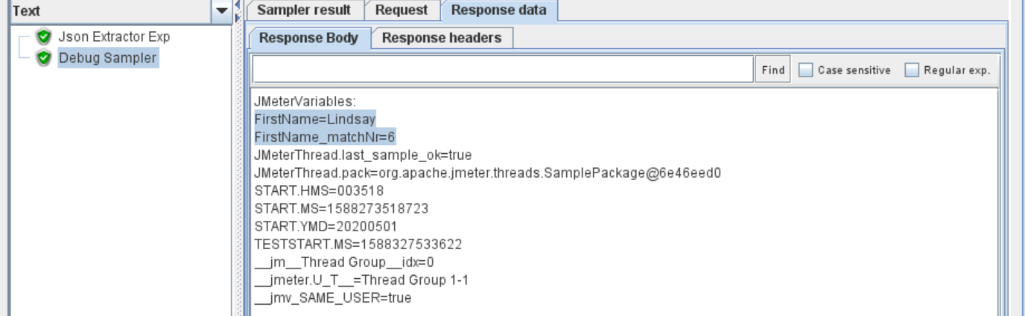

1. To extract first and last name from the 2nd data level. i.e. ‘Lindsay’ ‘Furguson’

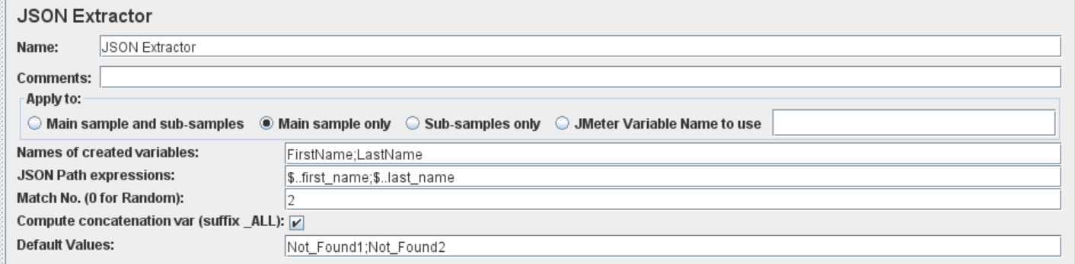

Output=

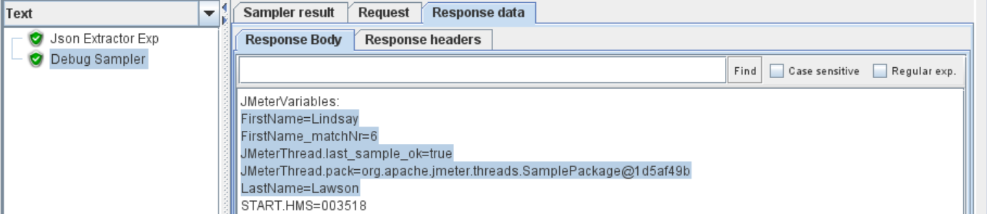

Json Path Exp=$..first_name;$..last_name

FirstName=Lindsay

LastName=Lawson

FirstName_matchNr=6

--This is wrong. This is not giving first name and last name for 2nd data level from Json response.

-- So, this Json expression is valid where there is only one Json response and we want to extract two or multiple values from that json response.

-- If we have multiple data levels in json response, and if we want to extract first name and last name where id=8 (i.e. from 2nd level), then we need to have the different Json Path expressions.

1. If we use Match Value=-1 then it will give all the first names but only one random last name as below

firstname_1=Michael

firstname_2=Lindsay

firstname_3=Tobias

firstname_4=Byron

firstname_5=George

firstname_6=Rachel

firstname_ALL=Michael,Lindsay,Tobias,Byron,George,Rachel

firstname_matchNr=6

lastname=Lawson

1. Write the Json exp to get first name and last name where id=9.

Name of Variable=FirstName;LastName

Json Path Exp=**$.data[?(@.id==9)].first_name;$.data[?(@.id==9)].last_name**

Match No=Blanck

Default Values=**Not_Found1;Not_Found2**

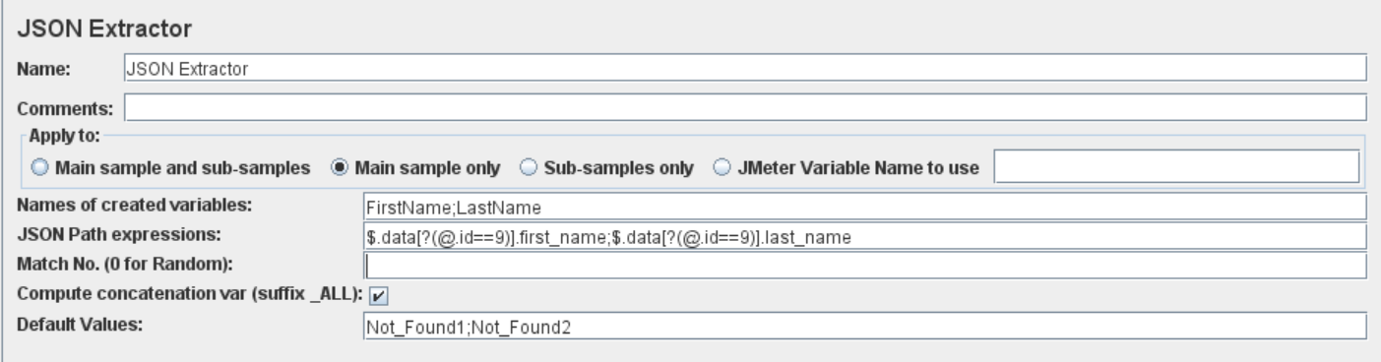

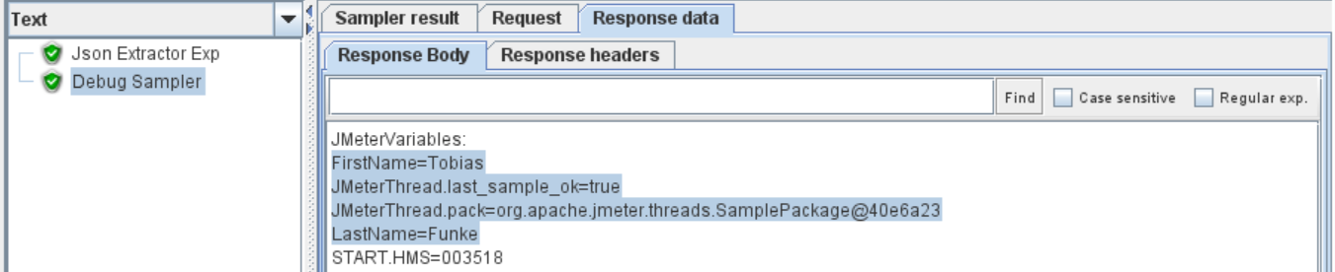

1. Write the Json exp to get id and email where first name=Lindsay

Name of Variable=id;email`

Json Path Exp= **$.data[?(@.first_name=='Lindsay')].id;$.data[?(@.first_name=='Lindsay')].email**

Matc No=Blanck

Default Values=**Not_Found1; Not_Found2**

output=

email=lindsay.ferguson@reqres.in

id=8